Principle of Data Base Management Systems

Prashanth.S(19MID0020**)**

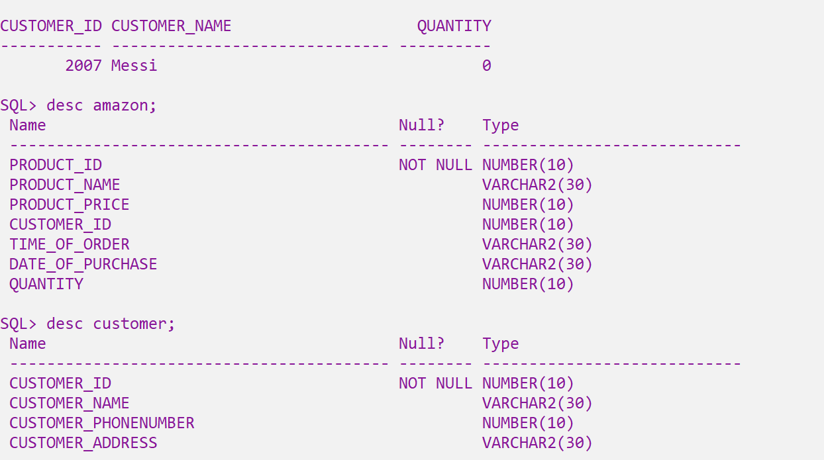

**Amazon table**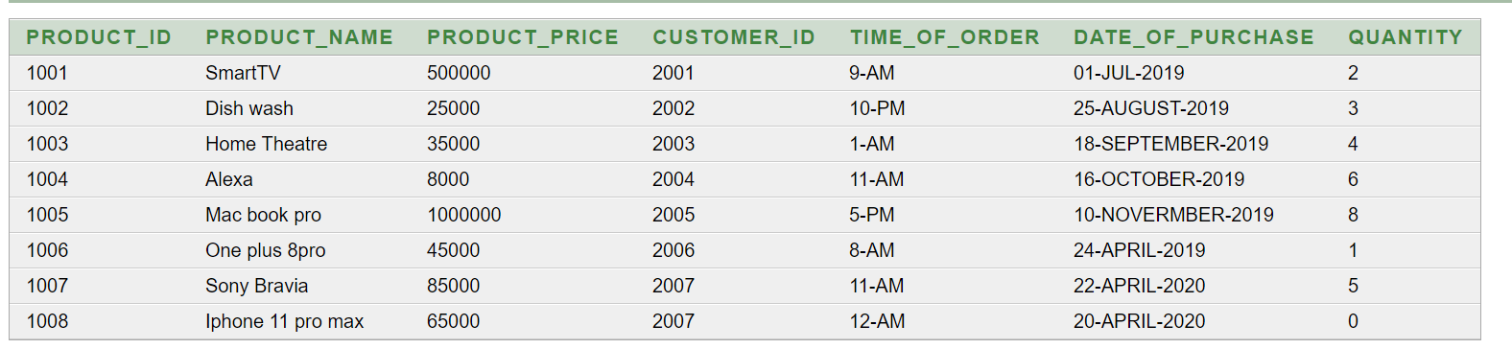

**Customer table**

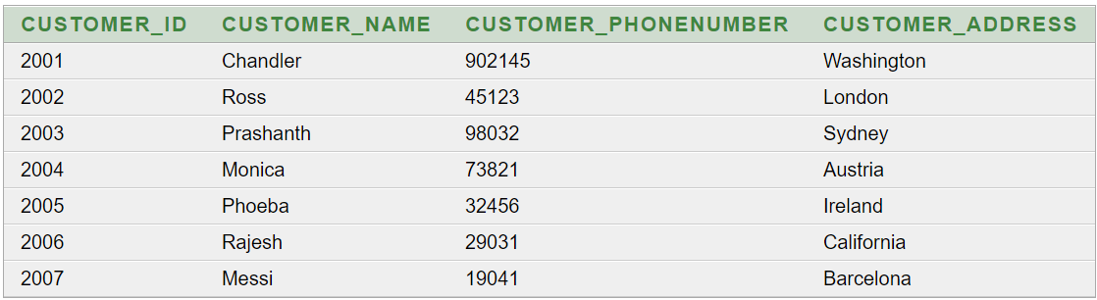

**Group Functions**

1)How many customers purchased more than 50000  
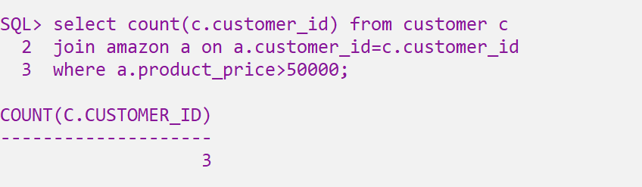

2) Print the maximum, minimum and the average amount of purchase.

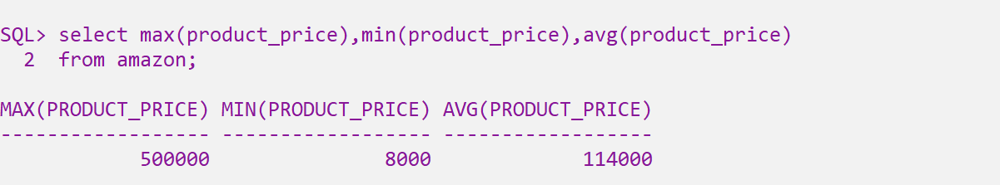

3) Find out the products pricing > 40000  
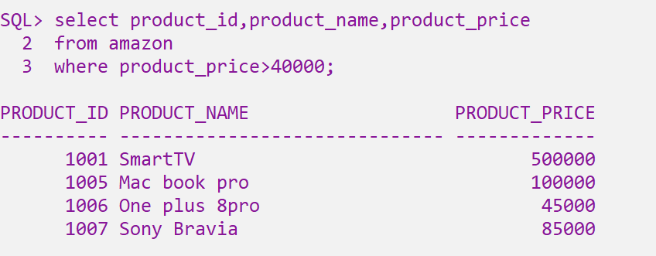

4) Display the number of customers along with the product in which the customer brought ‘pro’ products.  
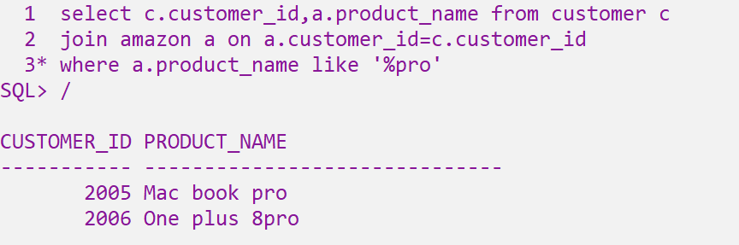

5) Determine the minimum amount spent by the customer on the purchase

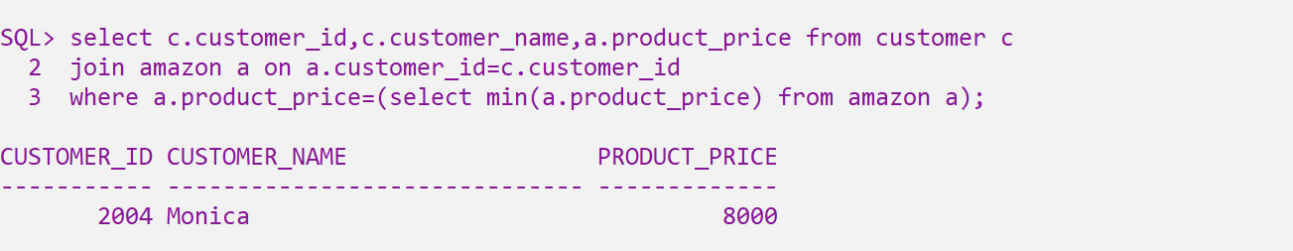

6) Calculate the average amount of purchase who purchases >50000  
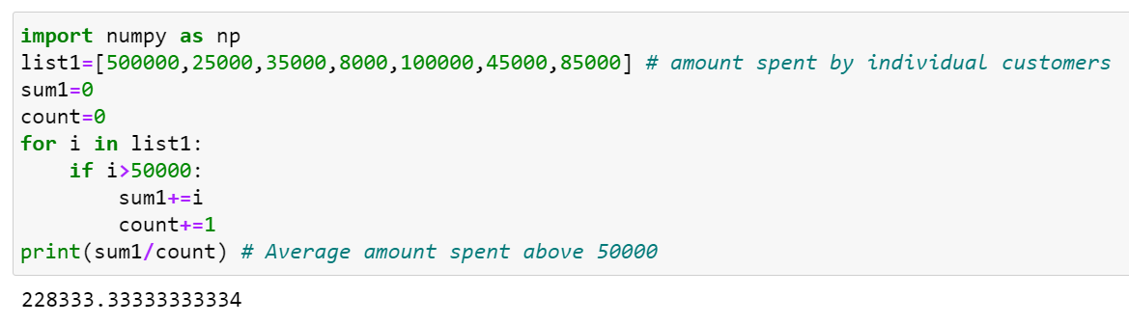  
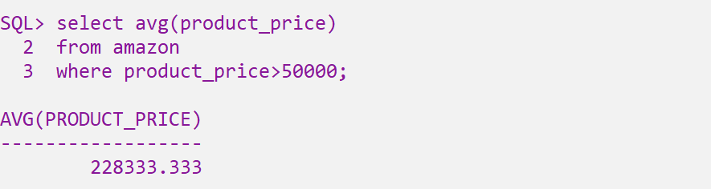

7) Display the total number of customers and total amount purchased.

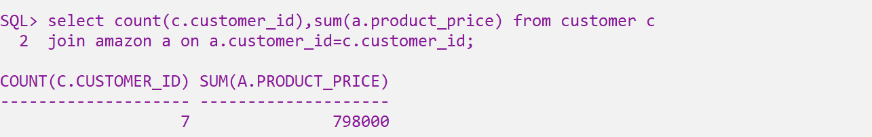

8) List the customers who bought minimum quantity of products

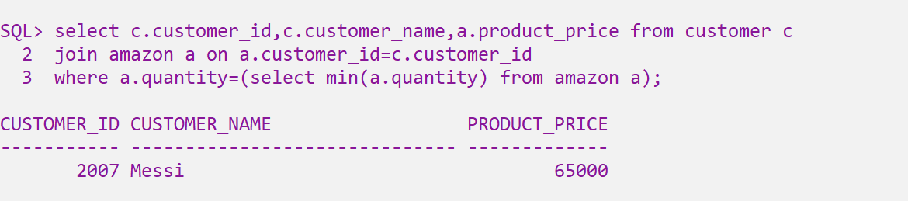

9) How many customers bought exactly 0 quantity of product???

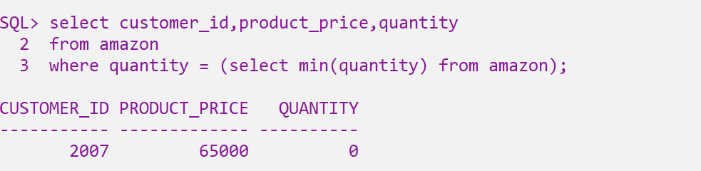

10) Get the customer and their respective purchase from ‘Austria’ .   
